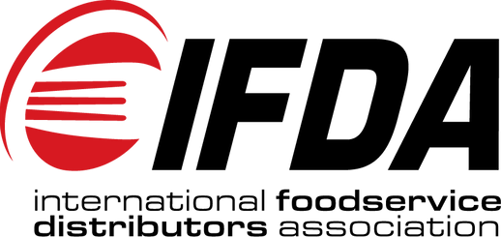

IFDA Member Code of Conduct

703.532.9400
info@ifdaonline.org 1660 International Drive Suite 550
McLean, VA 22102
The International Foodservice Distributors Association (IFDA) is the premier trade association for the foodservice distribution industry. IFDA contributes to the growth, development, and success of the foodservice distribution industry through our outstanding advocacy, events, research, and education.

IFDA is committed to fostering an environment that provides a safe, ethical and diverse community. IFDA members, partners, vendors and all organizations or individuals conducting business with IFDA are expected to uphold these same values across all IFDA programs and services.

We value the engagement of each participating company of the association. Association participants are expected to conduct themselves with integrity, courtesy and respect for others and maintain the highest level of professionalism. Any company and its representatives engaging with IFDA are required to observe this Code of Conduct.

The following guidelines are expectations for all persons participating in the Association’s programs and services.

Comply with all federal, state, and local laws, rules, and regulations.
Interact with others with respect, courtesy, and consideration, creating the space for everyone to actively contribute.
Avoid demeaning, discriminatory, or harassing communication (both spoken and written) behavior and materials with others.
Protect the Association’s proprietary and confidential information from inappropriate use or misappropriation.

To report a violation, please contact Mark Allen, President & CEO: mallen@ifdaonline.org

703.532.9400
1660 International Drive
Suite 550
McLean, VA 22102

info@ifdaonline.org

